

Systematic Review
Vasopressor therapy for septic shock after adequate fluid resuscitation in the emergency department: a systematic review and meta-analysis

Mazi Mohammed Alanazi¹, Rayan Ahmed Bahmaid², Reema Meshal Aldera²
- Saudi and Jordanian Board Emergency Medicine, Emergency Department, Head of Emergency Research Unit, First Health Cluster, Riyadh, Saudi Arabia
- Saudi board emergency Medicine Resident, Prince Sultan Military Medical City, Riyadh, Saudi Arabia

ABSTRACT
Background: Septic shock is a critical emergency, and vasopressor timing after initial fluid resuscitation is under debate. Data from emergency department, prehospital, and intensive care studies benefit from earlier norepinephrine initiation. Methods: We performed a systematic review and meta-analysis of studies evaluating vasopressor therapy, norepinephrine in septic shock after fluid resuscitation, with focus on timing of initiation. Nine studies were included in the qualitative analysis, while studies with extractable event counts were entered into the mortality meta-analysis. Pooled risk ratios (RRs) were calculated for short-term and 28-day mortality. Results: Earlier vasopressor initiation was associated with better hemodynamic and clinical outcomes in the included studies, including faster shock control, lower fluid exposure, and less organ failure progression. In the pooled short-term mortality analysis of four studies, early vasopressor initiation was associated with lower mortality (RR 0.72, 95% CI 0.56–0.92; I²=0%). In the stricter 28-day mortality analysis of three studies, early initiation also favored survival (RR 0.66, 95% CI 0.51–0.86; I²=0%). Conclusion: Early norepinephrine initiation improved short-term outcomes in septic shock. More high-quality emergency department studies are needed to define the best timing threshold and confirm the effect on mortality.
Keywords: septic shock; norepinephrine; vasopressors; emergency department; fluid resuscitation

Published: March 31, 2026
https://doi.org/10.65759/ggs92j37
Copyright © 2025 The Author(s). Published by Lizzy B. This is an open-access article distributed under the terms of the Creative Commons Attribution (CC BY 4.0) license, which permits unrestricted use, distribution, and reproduction in any medium, provided the original work is properly cited).

Introduction
Sepsis is defined as an organ dysfunction caused by a dysregulated host response to infection, while septic shock is the severe subgroup in which circulatory, cellular, and metabolic abnormalities increase the risk of death beyond sepsis [1,2]. Sepsis and septic shock were major health problem, with high morbidity and mortality despite advances in antimicrobials, intensive care, and resuscitation strategies, which is why they are still a major concern in ED and critical care practice [1,3,4]. The ED is important in this condition because septic shock is time dependent, and early decisions about fluids, and source-directed treatment influence later organ failure and survival [1,5,6]. Initial resuscitation is based on crystalloids together with hemodynamic reassessment, but current studies emphasize that septic shock is not only a fluid problem, because vasoplegia, vascular leakage, and microcirculatory dysfunction are major parts of the syndrome [1,2,7].
Norepinephrine become the preferred first-line vasopressor in adult septic shock in recent reviews, because it restores vascular tone effectively and compares favorably with other vasopressors in safety and hemodynamic performance [3,4,8]. The best timing of norepinephrine still controversial, because clinicians have traditionally waited for larger fluid loading, while newer studies indicate that delaying vasopressors prolong hypotension, worsen organ perfusion, and increase fluid overload [7,9,10]. The longest delays in vasopressor initiation were associated with higher odds of worsening organ failure, even though 28-day mortality was not associated with timing in that analysis [5]. Early norepinephrine improved shock control by 6 hours compared with standard treatment, as earlier vasopressor support stabilizes patients faster during the first phase of septic shock resuscitation [11].
More recent reviews and meta-analyses have shown a trend favoring earlier norepinephrine, including lower mortality, less fluid administration, and faster achievement of target mean arterial pressure in some analyses [9,10]. Another practical issue in the ED is safety, because vasopressor initiation is delayed while waiting for central access, although ED data indicate that carefully monitored peripheral norepinephrine can be used with a low rate of adverse events under protocolized care [2,6]. A focused systematic review on vasopressor therapy for septic shock after adequate fluid resuscitation in the ED is justified, because the available literature mixes ED, ICU, and prehospital studies and does not fully answer the exact bedside question faced by ED physicians.
Methods
This study was designed as a systematic review and meta-analysis to evaluate vasopressor therapy, in adult patients with septic shock after fluid resuscitation. The review question was centered on whether earlier vasopressor use was associated with better outcomes than delayed initiation in septic shock patients treated in acute care settings, especially the ED. The review included comparative original studies that assessed early versus delayed vasopressor or norepinephrine initiation and reported mortality, shock control, organ failure progression, fluid volume, or time to achieve target mean arterial pressure.
Studies were considered eligible if they enrolled adults with septic shock, evaluated vasopressor timing, and provided original comparative data. Randomized controlled trials, prospective cohort studies, retrospective cohort studies, and propensity score-based observational studies were eligible for inclusion.
Data extraction was carried out for study characteristics, country, design, setting, sample size, vasopressor definition, timing threshold for early versus delayed treatment, and reported outcomes. Our attention was given to mortality outcomes, because these were used for meta-analysis whenever raw event counts were available. When possible, additional data were extracted for shock control by 6 hours, organ failure progression, time to target MAP, fluid exposure, and adverse events.
For quantitative synthesis, only studies with extractable event counts for mortality were pooled. Risk ratios with 95% CIs were calculated for short-term mortality, and a separate pooled analysis was performed for 28-day mortality only. Heterogeneity in studies was assessed using the I² statistic. Studies that did not provide 2×2 event data, or not structured as simple comparative mortality studies, were included in the qualitative synthesis only. Because the available evidence was heterogeneous in design, setting, and definition of early treatment, the pooled results were interpreted with caution and in light of the clinical context of each included study.

Results
Nine studies were included in qualitative synthesis and studies were published between 2014 and 2025 and evaluated the timing of norepinephrine or vasopressor initiation in septic shock. The included studies consisted of one randomized controlled trial, several retrospective cohort or propensity score-based studies, one prospective cohort study, and one brief multicenter observational study. The studies were done in different settings, including the ED, prehospital mobile ICU, and ICU. The definition of vasopressor initiation was not the same in studies, ranging from within 1 hour to within 3 hours, or started at the beginning of resuscitation.
In the CENSER randomized trial, 310 adults with sepsis and hypotension were randomized into early norepinephrine and standard treatment groups. Median time from emergency room arrival to norepinephrine was shorter in the early group than in the standard group (93 vs 192 minutes). Shock control by 6 hours was higher in the early norepinephrine group (76.1% vs 48.4%, p<0.001). 28-day mortality was not significantly different between groups (15.5% vs 21.9%, p=0.15). The early group had lower rates of cardiogenic pulmonary edema and new-onset arrhythmia.
In the retrospective ED study by Black et al., the median time to vasopressor initiation was 6 hours, and norepinephrine was the most used vasopressor. The primary composite outcome of worsening organ failure or death at 48 hours occurred in 152 patients. A delay of 20 to 24 hours to vasopressor initiation was associated with higher odds of worsening organ failure compared with vasopressor initiation within the first 4 hours (OR 4.34, 95% CI 1.47–12.79, p=0.008).
Messina et al. analyzed 127 septic shock patients who received norepinephrine in the ED and focused on safety. Side effects related to norepinephrine were reported in five patients (3.9%). The authors concluded that peripheral norepinephrine infusion in the ED is safe for less than 12 hours when used under a specific protocol. ED management variables were not associated with mortality except for ICU admission.
Bai et al. reported higher mortality in the delayed group (43.3% vs 29.1%), and each 1 hour delay during the first 6 hours was associated with a 5.3% increase in mortality. Xu et al. found lower 28-day mortality with norepinephrine started within 3 hours (30.0% vs 37.8%) and less organ failure progression. Ospina-Tascón et al. reported lower day-28 mortality with very early vasopressor start (HR 0.31, 95% CI 0.17–0.57). Li et al. found lower 28-day mortality with initiation within 1 hour (28.6% vs 47.4%). Abe et al. did not show a significant mortality difference between early and delayed vasopressor groups.

Table 1. Study characteristics and methodological extraction
Study | Country | Design | Setting | Population and sample | Exposure and comparator | Outcomes
Permpikul et al., 2019 [11] | Thailand | Single-center phase II randomized, double-blind, placebo-controlled trial | Emergency room, tertiary hospital | Adults with sepsis and hypotension; n=310 (155 early NE, 155 standard treatment) | Early low-dose norepinephrine plus fluid resuscitation at initiation of hypotension resuscitation vs placebo/standard treatment; median time from ER arrival to NE 93 vs 192 min | Shock control by 6 h, 28-day mortality, organ support, adverse events
Black et al., 2020 [5] | USA | Retrospective cohort | Septic shock within 24 h of ED presentation | Septic shock; n=428 | Time to vasopressor initiation from ED triage categorized as 0–4, 4–8, 8–12, 12–16, 16–20, 20–24 h | Worsening organ failure at 48 h or death, 28-day mortality
Messina et al., 2021 [6] | Italy | Retrospective analysis | Tertiary hospital ED | Septic shock patients receiving peripheral norepinephrine in ED; n=127 | No early timing comparison; protocol-guided peripheral norepinephrine infusion in ED | Local/systemic adverse effects, in-hospital mortality, ED variables
Jouffroy et al., 2022 [12] | France | Retrospective propensity-based study | Prehospital mobile ICU | Septic shock requiring prehospital MICU; n=478 | Prehospital norepinephrine to reach MAP >65 mmHg vs no prehospital norepinephrine | 30-day mortality
Bai et al., 2014 [13] | China | Retrospective cohort | Two general surgical ICUs | Adult septic shock; n=213 | Early NE <2 h vs late NE ≥2 h after septic shock onset | 28-day mortality, MAP, lactate, duration of hypotension, NE exposure
Ospina-Tascón et al., 2020 [14] | Colombia | Propensity score-based analysis | Mixed ICU | Sepsis requiring vasopressor support ≥6 h; 337 initially selected, matched cohort 93 vs 93 | Very early norepinephrine within/before the next hour of first resuscitative fluid load vs delayed start | 28-day mortality, fluid balance, renal outcomes
Xu et al., 2022 [15] | USA database / China authors | Retrospective propensity score-matched cohort | ICU database | Septic shock; 4253 total, PSM cohort 2862 | Early NE within 3 h vs delayed >3 h, regardless of preload dependency | 28-day mortality, survival days, ICU/hospital LOS, organ failure progression, fluid volume
Abe et al., 2023 [16] | Japan | Multicenter observational study | 17 ICUs at tertiary hospitals | Septic shock patients receiving vasopressors; n=97 | Early vasopressor ≤1 h from sepsis recognition vs delayed >1 h | In-hospital mortality, fluid trend
Li et al., 2025 [4] | China | Prospective cohort | ICU of tertiary general hospital | Septic shock; n=120 (42 early, 78 late) | Early NE ≤1 h vs late >1 h after shock onset | 28-day mortality, time to MAP ≥65, 24-h fluid volume, 6-h lactate clearance, LOS, CRRT

Table 2. Outcome extraction and key quantitative findings
Study | Main quantitative findings | Effect estimates and statistics | Safety findings
Permpikul et al., 2019 | Shock control by 6 h: 76.1% vs 48.4%; 28-day mortality: 15.5% vs 21.9%; median ER-to-NE time: 93 vs 192 min | Shock control OR 3.4, 95% CI 2.09–5.53, p<0.001; mortality RR 0.79, 95% CI 0.53–1.11, p=0.15 | Lower cardiogenic pulmonary edema (14.4% vs 27.7%, p=0.004) and new-onset arrhythmia (11% vs 20%, p=0.03)
Black et al., 2020 | 152/428 had composite worsening organ failure/death at 48 h; 77 died within 48 h and 75 had SOFA increase ≥2 | Compared with 0–4 h, 20–24 h delay had OR 4.34, 95% CI 1.47–12.79, p=0.008 for worsening organ failure; no association with 28-day mortality | Not a safety-focused study
Messina et al., 2021 | 127 patients analyzed; 30 transferred to ICU, 28 ceiling-of-care, 69 to wards | ICU admission was the only variable associated with in-hospital mortality: OR 4.48, 95% CI 1.52–13.22, p=0.007 | Adverse events requiring discontinuation in 3.9%; one confirmed extravasation reported as 0.78%; authors considered peripheral NE in ED reasonably safe for <12 h under protocolized monitoring
Jouffroy et al., 2022 | 143/478 received prehospital NE; among these, 84 were alive and 38 deceased at day 30; overall 30-day mortality 30% | Adjusted HR 0.42, 95% CI 0.25–0.70, p<10⁻³; IPTW adjusted OR 0.75, 95% CI 0.70–0.79, p<10⁻³ | No major safety signal highlighted in the abstract snippet
Bai et al., 2014 | Average time to NE 3.1 ± 2.5 h; late initiation associated with worse hemodynamics and lactate profile | Every 1-hour delay in first 6 h associated with 5.3% increase in mortality; late group had significantly higher 28-day mortality, but exact group percentages were not available in the retrieved text | No major safety comparison extracted from the retrieved text
Ospina-Tascón et al., 2020 | At vasopressor start: fluids 0 [0–510] vs 1500 [650–2300] mL; first 8 h fluids 1100 [500–1900] vs 2600 [1600–3800] mL | Day-28 mortality HR 0.31, 95% CI 0.17–0.57, p<0.001 | No significant increase in acute renal failure or renal replacement therapy
Xu et al., 2022 | In PSM cohort, 28-day mortality 30.0% vs 37.8%; fluid therapy 0 vs 79 mL/kg; organ failure progression 64.4% vs 79.2%; ICU stay 4.9 vs 7.2 d; hospital stay 12.4 vs 13.6 d | Discussion reports early NE associated with reduced 28-day mortality, OR 0.545, p<0.001 | No major adverse-effect signal extracted in the retrieved text
Abe et al., 2023 | Early group 67, delayed group 30; in-hospital mortality 32.8% vs 26.7%; median 6-h fluid 3000 vs 2645 mL | Adjusted OR for in-hospital mortality 0.76, 95% CI 0.17–3.29; not statistically significant | No major safety signal extracted
Li et al., 2025 | 28-day mortality 28.6% vs 47.4%; time to MAP ≥65: 1.0 vs 1.5 h; 24-h fluid 3605 vs 3930.5 mL; 6-h lactate clearance 40.7% vs 14.9% | Time to NE >1 h independently associated with mortality: OR 4.564, 95% CI 1.382–15.079, p=0.013 | No major adverse-effect comparison extracted

Fig 1: all cause short term mortality
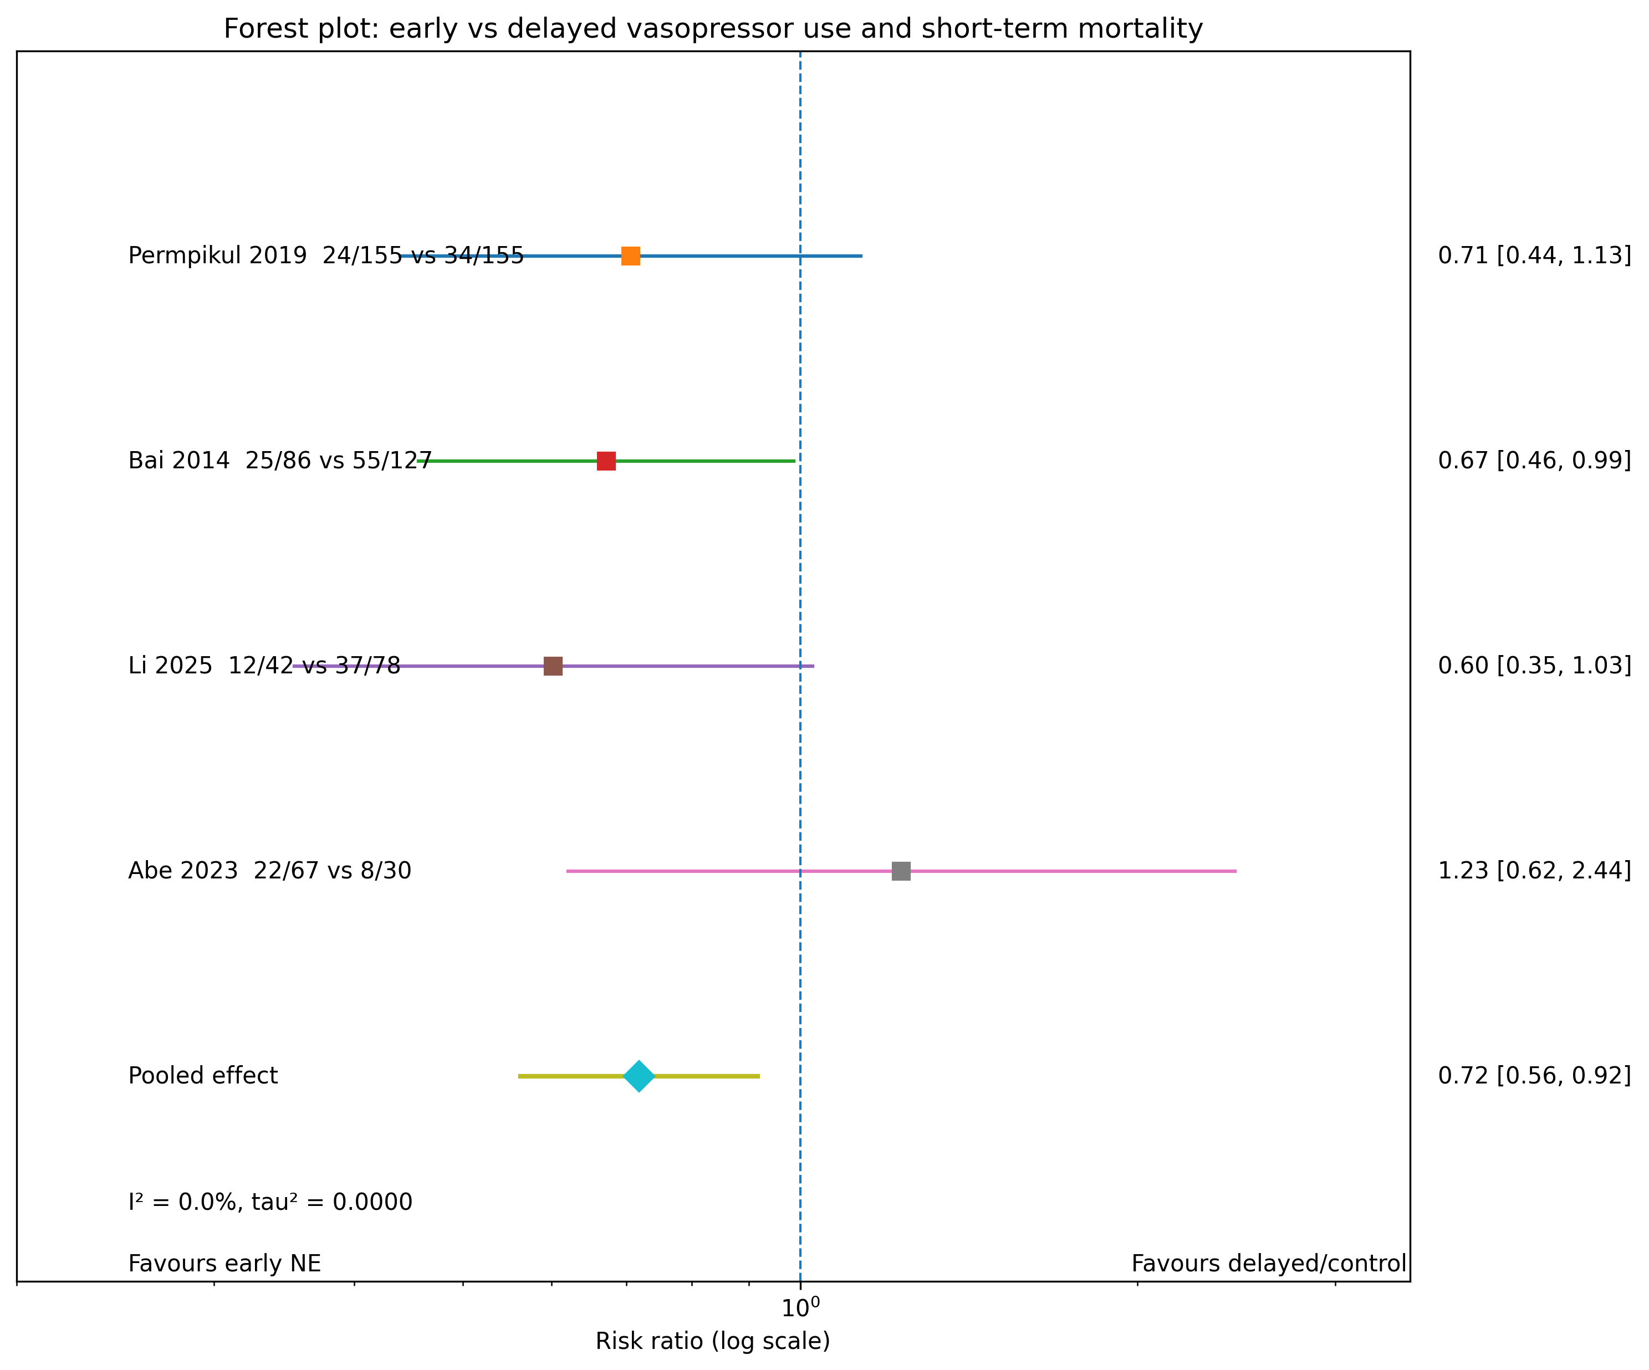

Fig 2: 28-day mortality Meta-analysis summary CSV
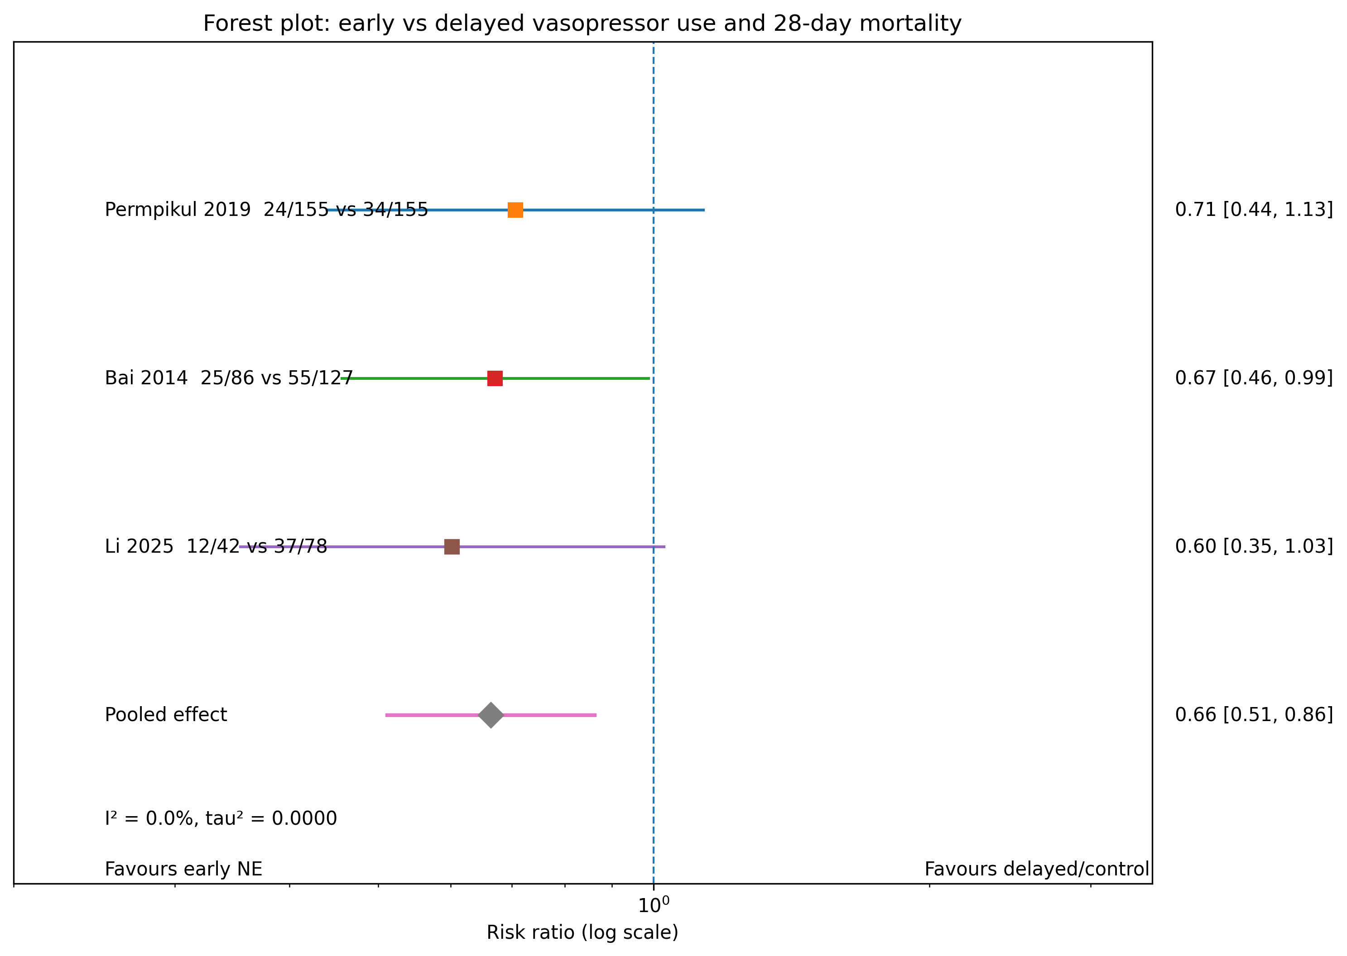

Discussion
Earlier vasopressor initiation favored better short-term outcomes, supporting the idea that delaying vasopressor therapy after persistent hypotension worsen the course of septic shock [11,14,15]. This pattern is clinically significant because the benefit of early treatment was seen in mortality-related outcomes and also in hemodynamic and organ-related outcomes in several included studies [5,11,15]. The CENSER trial showed that early norepinephrine improved shock control by 6 hours and shortened the time from ED arrival to vasopressor administration, even though the 28-day mortality difference was not statistically significant, which indicate that earlier vasopressor use appear as physiologic stabilization before a clear mortality effect is seen in individual trials [11].
The observational evidence moved in the same direction, because Black and colleagues found that very long delays associated with worsening organ failure in ED patients, and Xu and colleagues found lower 28-day mortality, less fluid exposure, and less organ failure progression with norepinephrine started within 3 hours, and Ospina-Tascón and colleagues reported lower day-28 mortality and smaller fluid balances with early vasopressor strategy [5,14,15].
Hypotension in sepsis is not caused by hypovolemia alone but also by vasoplegia, vascular leakage, reduced stressed volume, and microcirculatory dysfunction, so fluids alone insufficient in many patients [2,7,17]. Early norepinephrine help by restoring vascular tone, increasing venous return, recruiting endogenous fluid, and reaching the initial MAP target faster, which shorten the duration of harmful hypotension and reduce the need for excessive fluid administration [7,9,18].
This interpretation is supported by reviews showing that prolonged hypotension is associated with worse outcomes and that fluid overload itself delay recovery, prolong ICU stay, and increase mortality, which makes a combined fluid-plus-vasopressor strategy more logical than a prolonged fluid-only approach in fluid-resistant shock [2,7]. From the ED perspective, this issue is important because the ED is where the first major decisions are made, and our topic focuses on that phase in which clinicians must decide whether persistent hypotension after adequate fluid resuscitation should trigger vasopressor initiation without unnecessary delay [1,5,17].
Messina and colleagues reported a low rate of adverse events with protocol-guided peripheral norepinephrine infusion, and later reviews also noted that serious extravasation complications appear uncommon when peripheral vasopressors are carefully monitored, which reduces one practical barrier to earlier treatment [2,6]. Our findings should still be interpreted carefully because the included evidence was heterogeneous, timing definitions, and outcome measures, and many studies were ICU-based rather than ED studies after documented adequate fluid resuscitation, which limits how confidently the results applied to the exact ED population of interest [5,9,10,15]. Our study found that earlier norepinephrine is beneficial once septic shock were unresolved after initial fluid resuscitation, but more high-quality ED studies are needed to define the best timing threshold and to separate the effect of early vasopressors from differences in shock severity, fluid strategy, and local ED practice [1,10,11].

Conclusion
Early vasopressor initiation with norepinephrine improves short-term outcomes in septic shock, in relation to shock control, organ dysfunction, fluid burden, and mortality. The available literature was heterogeneous in study design, setting, and timing definitions, and some of the data came from ICU-based rather than ED populations. Early norepinephrine is beneficial after initial fluid resuscitation, stronger ED-specific studies are needed to define the optimal timing and confirm the mortality benefit in clearly fluid-resuscitated patients.

References
[1] Guarino M, Perna B, Cesaro AE, Maritati M, Spampinato MD, Contini C, et al. 2023 Update on Sepsis and Septic Shock in Adult Patients: Management in the Emergency Department. J Clin Med 2023;12. https://doi.org/10.3390/jcm12093188.
[2] Graham JD, Lanspa MJ, Peltan ID. Resuscitation Targets, Fluids, and Vasoactives in Septic Shock. Clin Chest Med 2025. https://doi.org/10.1016/j.ccm.2025.10.003.
[3] Ruslan MA, Baharuddin KA, Noor NM, Yazid MB, Noh AYM, Rahman A. Norepinephrine in septic shock: A systematic review and meta-analysis. Western Journal of Emergency Medicine 2021;22:196–203. https://doi.org/10.5811/WESTJEM.2020.10.47825.
[4] Xu QY, Jin YH, Fu L, Li YY. Application of norepinephrine in the treatment of septic shock: a meta-analysis. Ir J Med Sci 2025;194:361–9. https://doi.org/10.1007/s11845-024-03827-x.
[5] Black LP, Puskarich MA, Smotherman C, Miller T, Fernandez R, Guirgis FW. Time to vasopressor initiation and organ failure progression in early septic shock. JACEP Open 2020;1:222–30. https://doi.org/10.1002/emp2.12060.
[6] Messina A, Milani A, Morenghi E, Costantini E, Brusa S, Negri K, et al. Norepinephrine infusion in the emergency department in septic shock patients: A retrospective 2-years safety report and outcome analysis. Int J Environ Res Public Health 2021;18:1–9. https://doi.org/10.3390/ijerph18020824.
[7] Carlos Sanchez E, Pinsky MR, Sinha S, Mishra RC, Lopa AJ, Chatterjee R. Fluids and Early Vasopressors in the Management of Septic Shock: Do We Have the Right Answers Yet? J Crit Care Med 2023;9:138–47. https://doi.org/10.2478/jccm-2023-0022.
[8] Zhou F, Mao Z, Zeng X, Kang H, Liu H, Pan L, et al. Vasopressors in septic shock: A systematic review and network meta-analysis. Ther Clin Risk Manag 2015;11:1047–59. https://doi.org/10.2147/TCRM.S80060.
[9] Zhou H-X, Yang C-F, Wang H-Y, Teng Y, He H-Y. Should we initiate vasopressors earlier in patients with septic shock: A mini systemic review. World J Crit Care Med 2023;12:204–16. https://doi.org/10.5492/wjccm.v12.i4.204.
[10] Shi R, Braïk R, Monnet X, Gu WJ, Ospina-Tascon G, Permpikul C, et al. Early norepinephrine for patients with septic shock: an updated systematic review and meta-analysis with trial sequential analysis. Crit Care 2025;29. https://doi.org/10.1186/s13054-025-05400-z.
[11] Permpikul C, Tongyoo S, Viarasilpa T, Trainarongsakul T, Chakorn T, Udompanturak S. Early use of norepinephrine in septic shock resuscitation (CENSER) a randomized trial. Am J Respir Crit Care Med 2019;199:1097–105. https://doi.org/10.1164/rccm.201806-1034OC.
[12] Jouffroy R, Hajjar A, Gilbert B, Tourtier JP, Bloch-Laine E, Ecollan P, et al. Prehospital norepinephrine administration reduces 30-day mortality among septic shock patients. BMC Infect Dis 2022;22. https://doi.org/10.1186/s12879-022-07337-y.
[13] Bai X, Yu W, Ji W, Lin Z, Tan S, Duan K, et al. Early versus delayed administration of norepinephrine in patients with septic shock. Crit Care 2014;18. https://doi.org/10.1186/s13054-014-0532-y.
[14] Ospina-Tascón GA, Hernandez G, Alvarez I, Calderón-Tapia LE, Manzano-Nunez R, Sánchez-Ortiz AI, et al. Effects of very early start of norepinephrine in patients with septic shock: A propensity score-based analysis. Crit Care 2020;24. https://doi.org/10.1186/s13054-020-2756-3.
[15] Xu F, Zhong R, Shi S, Zeng Y, Tang Z. Early initiation of norepinephrine in patients with septic shock: A propensity score-based analysis. American Journal of Emergency Medicine 2022;54:287–96. https://doi.org/10.1016/j.ajem.2022.01.063.
[16] Abe T, Umemura Y, Ogura H, Kushimoto S, Fujishima S, Saitoh D, et al. Early versus delayed vasopressor administration in patients with septic shock. Acute Medicine & Surgery 2023;10. https://doi.org/10.1002/ams2.852.
[17] Gavelli F, Castello LM, Avanzi GC. Management of sepsis and septic shock in the emergency department. Intern Emerg Med 2021;16:1649–61. https://doi.org/10.1007/s11739-021-02735-7.
[18] Shi R, Hamzaoui O, De Vita N, Monnet X, Teboul J-L. Vasopressors in septic shock: which, when, and how much? Ann Transl Med 2020;8:794–794. https://doi.org/10.21037/atm.2020.04.24.

